

Faculty: IT

Course Name: Digital Computer Fundamentals

Course Code: MATH 8127

Lecturer: Kundan Kumar

Group Members:

- MUTANGANA Joseph 29061
- HIRWA KALINDA Eloi 28789
- Kevin GATETE 29198

Report: Sequential circuit group assignment

Q1. A sequential circuit is a type of digital circuit where the output depends not just on the current inputs, but also on the past inputs

A sequential circuit gives output based on the current input + past states.

Sequential circuits include memory elements like flip-flops or latches.
These store the previous state, allowing the circuit to "remember" what happened before.

Q2. Different between sequential circuit and combination of circuit

Feature | Combination of circuit | Sequential circuit
Memory | No memory | Has memory
Outputs Depends on | Current input | Current inputs + Previous inputs
Examples | Adders, Multplexers | Filp-Flops, counters, registers
Timing | Instantaneous | Depends on clock or input change

Q3. Types of Sequential circuit

Types of Sequential Circuits Sequential circuits can be broadly categorized into two types based on how they handle state changes:

- Synchronous Sequential Circuits

        - Operate in sync with a clock signal
        - State changes occur only on the clock pulse
        - More predictable and easier to design/debug
        - Commonly used in digital systems

Examples of synchronous circuits:

- SR Flip-Flop (Clocked version):

- Two inputs: S (Set), R (Reset)
- If S=1 and R=0 → Output is set to 1
- If S=0 and R=1 → Output is reset to 0
- If S=R=1 → Invalid state (undefined)

- D Flip-Flop:

- Single input (D) and a clock input
- On clock edge, the output becomes equal to D
- Eliminates invalid states of SR

- JK Flip-Flop:

- Improvement over SR Flip-Flop
- Inputs J and K If J=K=1, the output toggles
- No invalid state

- Counters (using flip-flops):

- Count sequences (binary counting)
- Made by connecting flip-flops in series
- Used in clocks, timers, digital counters

These components change state only on a clock edge (like rising or falling edge).

2.Asynchronous Sequential Circuits

- Do not use a clock signal
- State changes happen immediately with input changes
- Faster but more complex due to potential for glitches or race conditions

Examples of asynchronous circuits:

- Basic (unclocked) SR Latch:

- Simple memory element without a clock
- Directly responds to S and R inputs

- Asynchronous Set/Reset circuits:

- Often used to reset systems when powered on
- Triggered by inputs, not clock pulses

These are useful for simple control logic, but are less common in modern large-scale systems.

Q4. Design of SR Flip-Flop

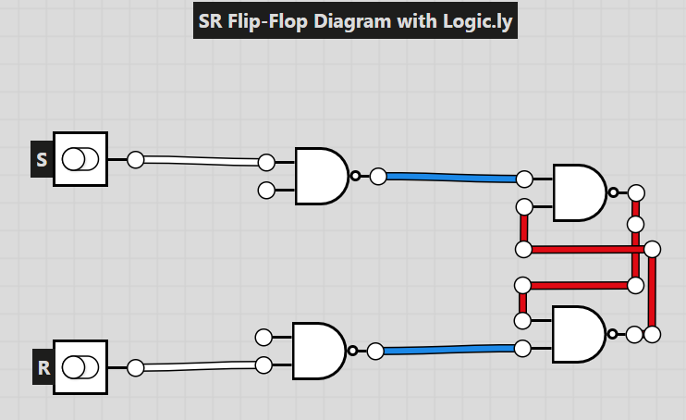

Truth table of SR flip-flop with NAND

S | R | Q | Q’ | State
0 | 0 | No change | No change | No change
0 | 1 | 0 | 1 | Reset
1 | 0 | 1 | 0 | Set
1 | 1 | Invalid | Invalid | Invalid State

